**Program-2**

**Count ways to reach the n’th stair**

There are n stairs, a person standing at the bottom wants to reach the top. The person can climb either 1 stair or 2 stairs at a time. Count the number of ways, the person can reach the top.

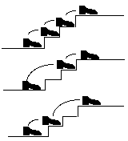

Consider the example shown in diagram. The value of n is 3. There are 3 ways to reach the top.   
   
**Note :- For all boundary conditions print -1**

 If the value of n is 3. There are 3 ways to reach the top.

**Constraints :-**

**N >0**

More Examples:

Input: n = 1

Output: 1

There is only one way to climb 1 stair

Input: n = 2

Output: 2

There are two ways: (1, 1) and (2)

Input: n = 4

Output: 5

(1, 1, 1, 1), (1, 1, 2), (2, 1, 1), (1, 2, 1), (2, 2)

**Test cases**

Input = 1

Output = 1

Input = 0

Output = -1

Input = 5

Output = 8

Input = 6

Output = 13

Input = 9

Output = 55